ASSIGNMENTS

NAME | K.NIKHIL
Team ID | LTVIP2026TMIDS62669
Project Name | Strategic Product Placement Analysis: Unveiling  Sales Impact with Tableau Visualization
Maximum Marks | 4 Marks

1 .Bar Chart

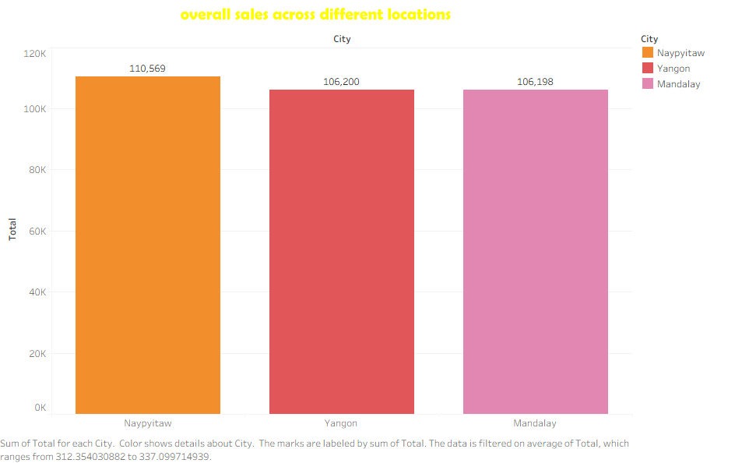

- . Pie Chart

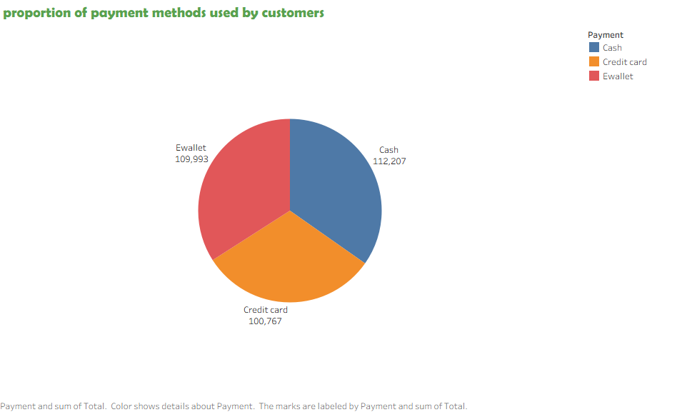
- . Stacked Bar Chart

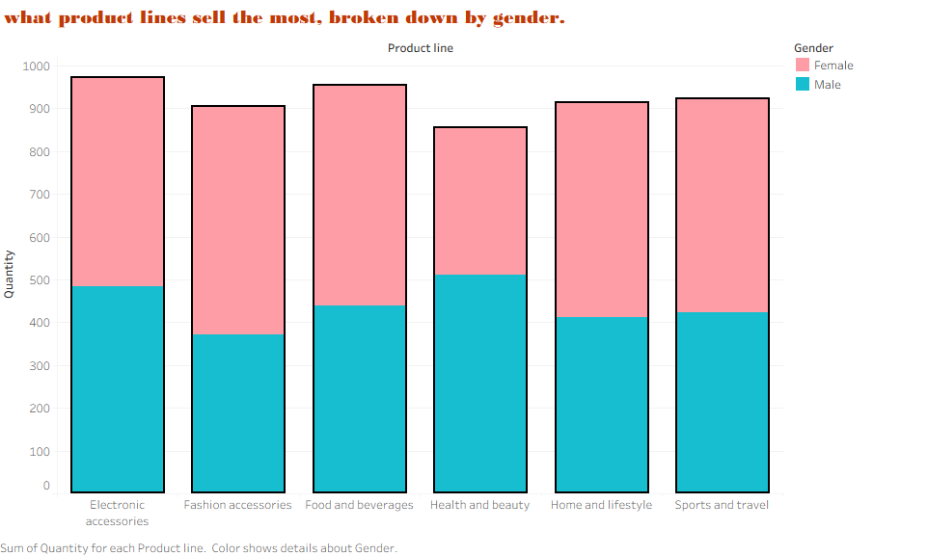
- . Line Chart
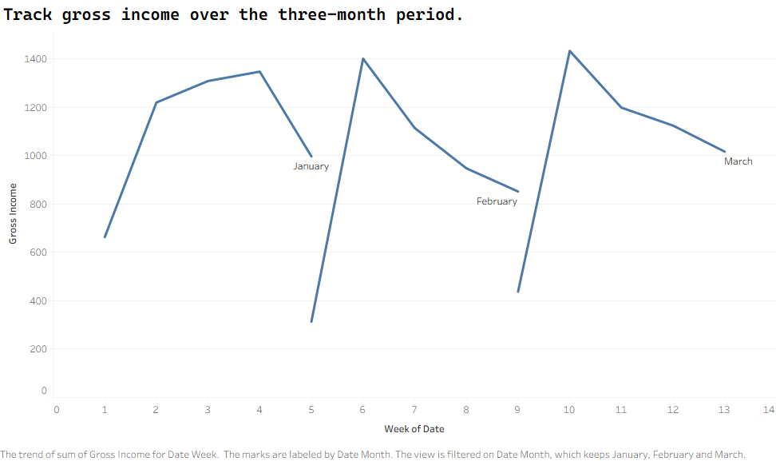
5 . Packed bubble chart

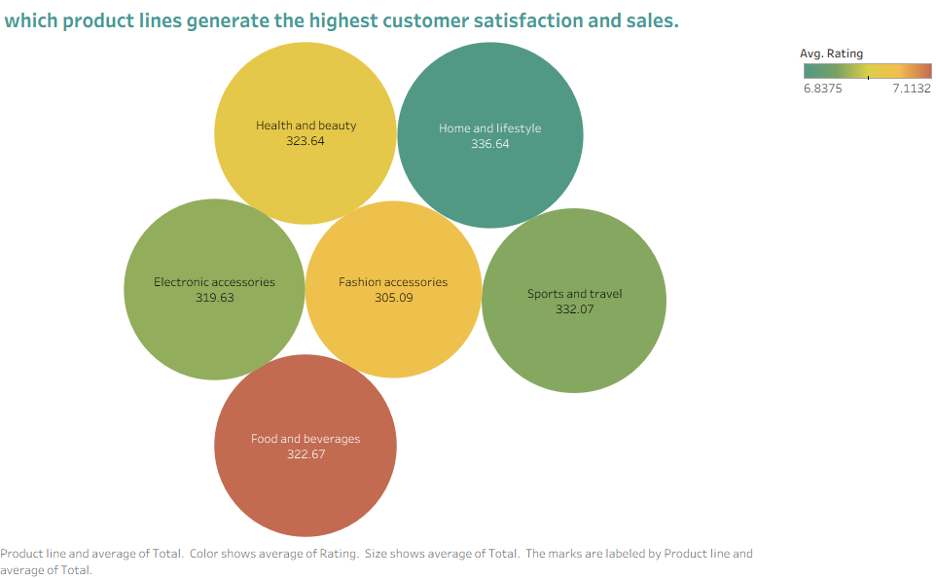
ASSIGNMENTS -2